# BLETOOL Manual

Version: BLETOOL _Manual_V0.8

Date: 2021-01-20

History

|  |  |  |
| --- | --- | --- |
| Version | Date | Description |
| 0.1 | 2019-04-18 | Initial |
| 0.2 | 2019-05-06 | Add connection, gatt operation commands |
| 0.3 | 2020-02-06 | Delete some commands and fix calibrate parameters and return values | 2019-5-06 | Add connection, gatt operation commands and error codes |
| 0.4 | 2020-03-26 | Add C/C++ API |  |  |
| 0.5 | 2020-03-30 | Change introductions |  |  |
| 0.6 | 2020-06-22 | Modify the callback function & the API parameters |  |  |
| 0.7 | 2020-12-15 | Change API parameters (" Connect "parameter changed to" Address "parameter) |  |  |
| 0.8 | 2021-01-20 | Add the Error Code section |  |  |

# Table of Contents

BLETOOL Manual 1

Table of Contents 2

1. Description 4

1.1 What’s bletool 4

1.2 How to install 4

1.3 How to use 5

2. API References 7

2.1 enable 7

2.2 local_address 7

2.3 set_power 8

2.4 listen 9

2.4.1 int32_t (*ble_module_event)(gl_ble_module_event_t event, gl_ble_module_data_t *data); 9

2.4.2 int32_t (*ble_gap_event)(gl_ble_gap_evrnt_t event, gl_ble_gap_data_t *data); 10

2.4.3 int32_t (*ble_gatt_event)(gl_ble_gatt_event_t event, gl_ble_gatt_data_t *data); 14

2.5 adv_data 16

2.6 adv 16

2.7 adv_stop 18

2.8 send_notify 19

2.9 discovery 19

2.10 stop 21

2.11 connect 22

2.12 disconnect 24

2.13 get_rssi 24

2.14 get_service 26

2.15 get_char 27

2.16 set_notify 29

2.17 read_value 30

2.18 write_value 31

3. Error Code 33

3.1 GL error code 33

3.2 Silconlabs error code 34

# 1. Description

## 1.1 What’s bletool

**BleTool** is a software develop kit for Bluetooth Low Energy (BLE) in GL-iNET’s products. It provides a basic and simple method for developers to operate all the BLE functions.

Different from BlueZ which includes the full Bluetooth protocol stack in the host system, bletool is a light weight tool to operate hostless BLE modules which has fully built-in protocol stack. The module can fully operate on itself rather than depending on the host system.

To use BleTool, you need to have one of the following devices.

* GL-S1300 (Convexa-S): Smarthome gateway with beamforming Wi-Fi
* GL-X750 (Spitz): LTE IoT gateway
* GL-XE300 (MEET PULI): Portable 4G LTE WiFi Hotspot with Security Features
* GL-MT300N-V2: (Mini Smart Router): Converting a public network (wired/wireless) to a private Wi-Fi for secure surfing.
* Gl-E750 (MEET MUDI): 4G LTE Privacy Router for Road Warriors
* GL-X300B (MEET COLLIE): 4G LTE Industrial Wireless Gateway
* GL-AP1300 (MEET CIRRUS): Enterprise Ceiling Wireless Access Point
* GL-B2200 (Velica): Whole home mesh system and gateway

You can also use BleTool if you use Silconlabs EFR32 BLE modules which use UART/SPI to connect to your host Linux.

## 1.2 How to install

By default, BleTool is not installed on your router. You can install it using opkg if you can ssh to the router.

opkg update

opkg install gl-bletool

Alternatively, you can install using the web UI. Login your router’s web UI using your browser which is http://192.168.8.1 by default. Then go to APPLICATIONS->Plug-ins. First click “Update” to refresh your software repo then search “gl-bletool”. Click “install” and wait until you got “installation successfully”.

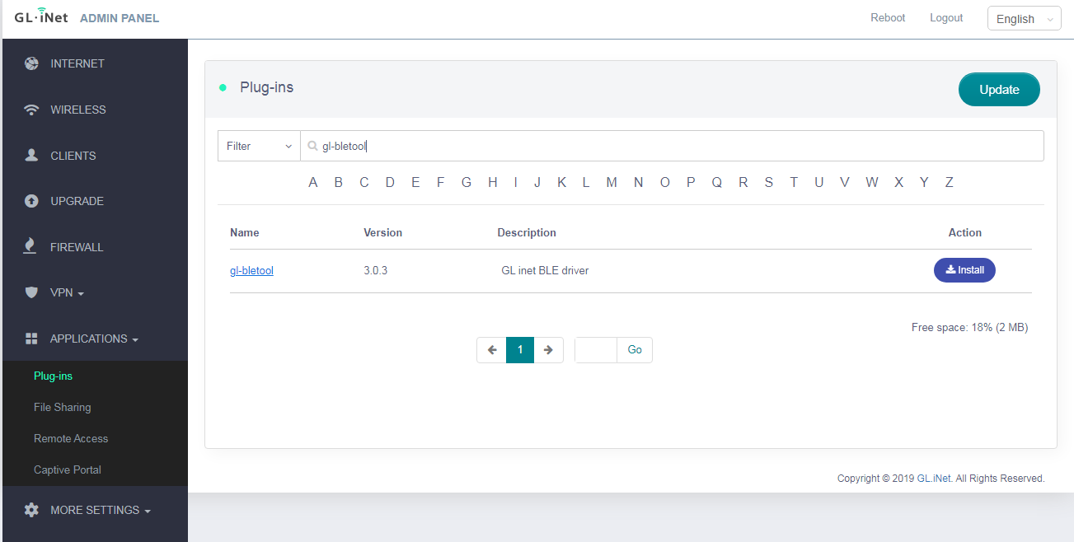

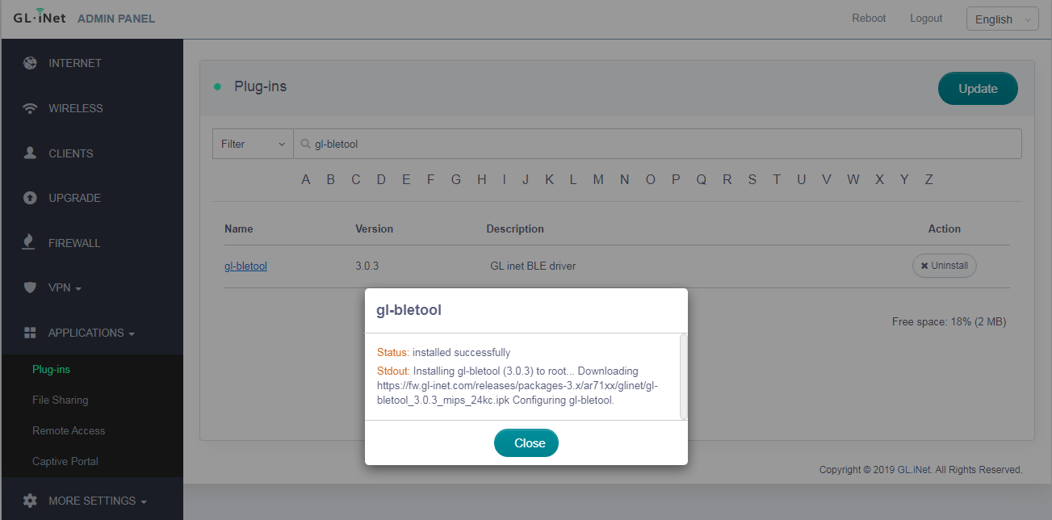

## 1.3 How to use

BleTool provides the following elements to handle BLE advertising, connection and GATT services.

* C/C++ APIs: This includes C functions, C header files based on which you can write your own code.
* C/C++ library: You can link this library with your own C application. You need to include the C header files in your own code to compile.
* cli (command line) tools: cli is commands that you can run in Linux terminal. You can use cli tools to test your BLE applications quickly and easily.

Here is example of how to use cli commands.

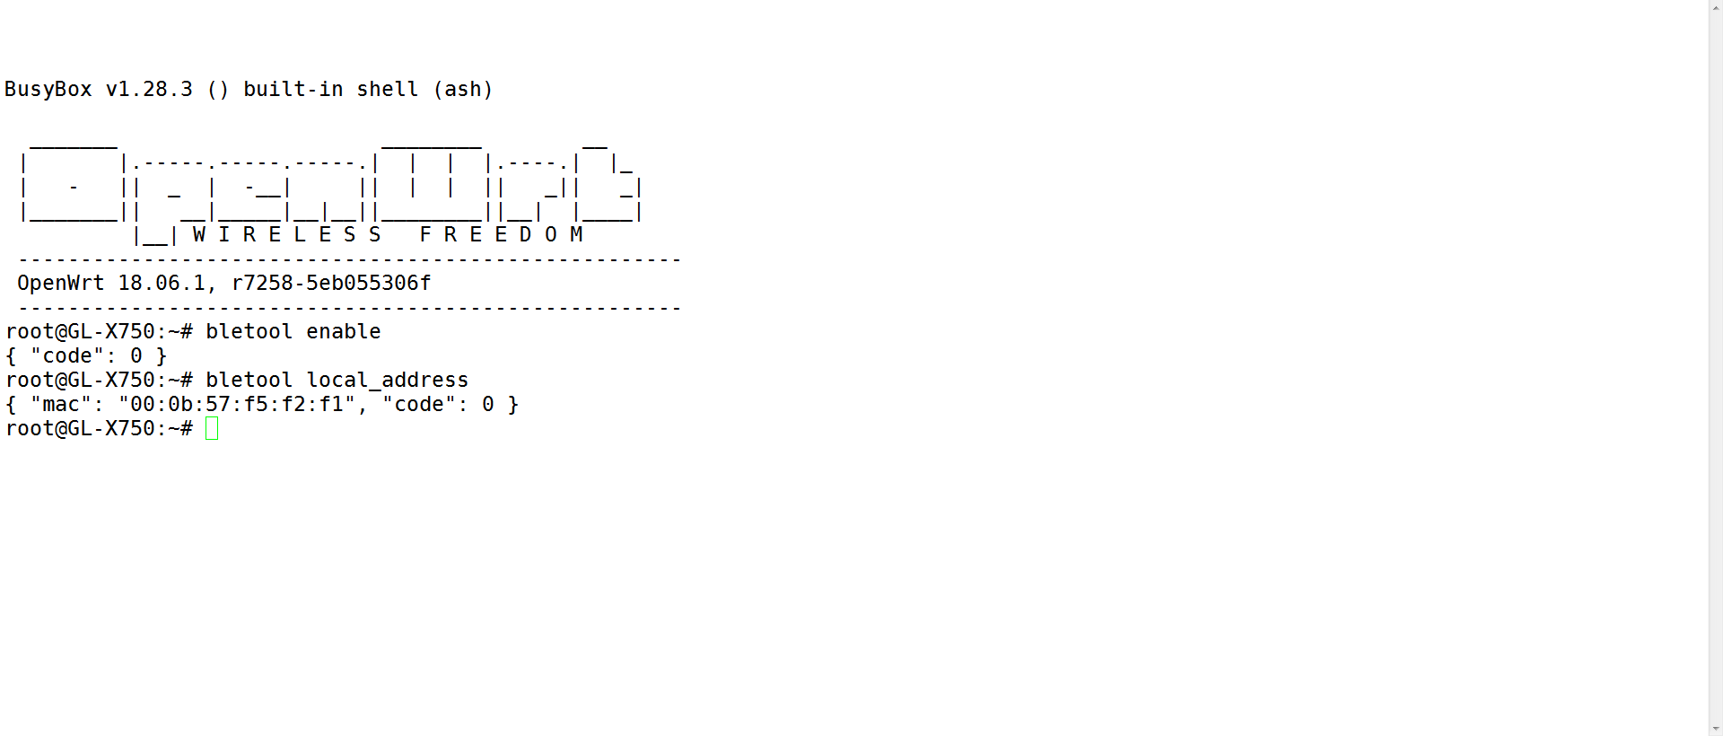

Below is the details of the API reference as well as the cli commands.

# 2. API References

Note that each API function will generate a message and pass to its fixed structure parameter after been called. It is a pointer to a structure. This should be appointed by user to handle the message.

Note: typedef int32_t GL_RET;

## 2.1 enable

Enable or disable the BLE hardware.

**C API:**

GL_RET gl_ble_enable(int32_t enable);

|  |  |  |
| --- | --- | --- |
| Parameters | | |
| Type | Name | Description | |
| int32_t | enable | 0 means disable the BLE hardware;  None-zero means enable the BLE hardware. | |

|  |  |  |
| --- | --- | --- |
| Result | | |
| Type | Name | Description | |
| int32_t | code | 0 means success;  None-zero means failed. | |

**CLI command:**

bletool enable 1

Parameters

|  |  |  |  |
| --- | --- | --- | --- |
| Type | Name | Default Value* | Description |
| int32_t | enable | 1 | 0 means disable the BLE hardware;  None-zero means enable the BLE hardware. |

Note that must call this command or API before using any other BLE commands or functions.

*\*A default value means you may not set this parameter. “-” means you must set this parameter.*

## 2.2 local_address

Get the Local Bluetooth MAC address.

**C API:**

GL_RET gl_ble_get_mac(gl_ble_get_mac_rsp_t *rsp);

|  |  |  |
| --- | --- | --- |
| Parameters | | |
| Type | Name | Description | |
| struct | rsp | A response structure that stores local Bluetooth MAC address | |

#define DEVICE_MAC_LEN 6

typedef struct {

uint8_t address[DEVICE_MAC_LEN];

} gl_ble_get_mac_rsp_t;

|  |  |  |
| --- | --- | --- |
| gl_ble_get_mac_rsp_t | | |
| Type | Name | Description | |
| uint8_t | address | The array of local Bluetooth MAC address | |

|  |  |  |
| --- | --- | --- |
| Result | | |
| Type | Name | Description | |
| int32_t | code | 0 means success;  None-zero means failed. | |
| uint8_t | address | Local Bluetooth address like “11:22:33:44:55:66” | |

**CLI command:**

bletool local_address

## 2.3 set_power

Set the global power level.

**C API:**

GL_RET gl_ble_set_power(gl_ble_set_power_rsp_t *rsp, int32_t power);

|  |  |  |
| --- | --- | --- |
| Parameters | | |
| Type | Name | Description | |
| struct | rsp | A response structure that stores the current power. | |
| int32_t | power | TX power in 0.1dBm steps, for example the value of 10 is 1dBm  and 55 is 5.5dBm | |

typedef struct {

int32_t current_power;

} gl_ble_set_power_rsp_t;

|  |  |  |
| --- | --- | --- |
| Result | | |
| Type | Name | Description | |
| int32_t | code | 0 means success;  None-zero means failed. | |
| int32_t | power | Actual adopted power level. | |

**CLI command:**

bletool set_power 80

Parameters

|  |  |  |  |
| --- | --- | --- | --- |
| Type | Name | Default Value | Description |
| int32_t | power | - | Power level |

## 2.4 listen

Listen to events generated from the BLE module.

**C API:**

int32_t gl_ble_subscribe(gl_ble_cbs *callback) ;

This function will subscribe events generate from BLE module. Note that it must be followed by uloop_run(), it will continuously pass events to function callback.

typedef struct{

int32_t (*ble_module_event)(gl_ble_module_event_t event, gl_ble_module_data_t *data);

int32_t (*ble_gap_event)(gl_ble_gap_evrnt_t event, gl_ble_gap_data_t *data);

int32_t (*ble_gatt_event)(gl_ble_gatt_event_t event, gl_ble_gatt_data_t *data);

} gl_ble_cbs;

### 2.4.1 int32_t (*ble_module_event)(gl_ble_module_event_t event, gl_ble_module_data_t *data);

Indicates that the device has started and the radio is ready. This event carries the firmware build number and other software and hardware identification codes. User can get system boot event and use it in this callback. This callback will be called when module receive a system boot event.

/* module callback event type */

typedef enum{

MODULE_BLE_SYSTEM_BOOT_EVT = 0,

MODULE_EVT_MAX,

} gl_ble_module_event_t;

|  |  |  |
| --- | --- | --- |
| gl_ble_module_event_t | | |
| Type | Name | Description | |
| enum | MODULE_BLE_SYSTEM_BOOT_EVT | BLE system event | |
| enum | MODULE_EVT_MAX | Event maximum | |

typedef union {

struct ble_system_boot_data{

int32_t major;

int32_t minor;

int32_t patch;

int32_t build;

int32_t bootloader;

int32_t hw;

char ble_hash[MAX_HASH_DATA_LEN];

} system_boot_data;

} gl_ble_module_data_t;

|  |  |  |
| --- | --- | --- |
| gl_ble_module_data_t | | |
| Type | Name | Description | |
| int32_t | major | Major release version | |
| int32_t | minor | Minor release version | |
| Int | patch | Patch release number | |
| Int | build | Build number | |
| Int | bootloader | Bootloader version | |
| Int | hw | Hardware type | |
| char | ble_hash | Version hash | |

### 2.4.2 int32_t (*ble_gap_event)(gl_ble_gap_evrnt_t event, gl_ble_gap_data_t *data);

Receive BLE GAP event from the module. User can get GAP event data and use it in this callback. This callback will be called when module receive a GAP event.

/* GAP BLE callback event type */

typedef enum{

GAP_BLE_SCAN_RESULT_EVT = 0,

GAP_BLE_UPDATE_CONN_EVT,

GAP_BLE_CONNECT_EVT,

GAP_BLE_DISCONNECT_EVT,

GAP_BLE_EVT_MAX,

} gl_ble_gap_evrnt_t;

|  |  |  |
| --- | --- | --- |
| gl_ble_gap_evrnt_t | | |
| Type | Name | Description | |
| enum | GAP_BLE_SCAN_RESULT_EVT | Scan result event | |
| enum | GAP_BLE_UPDATE_CONN_EVT | Update connection event | |
| enum | GAP_BLE_CONNECT_EVT | Connection event | |
| enum | GAP_BLE_DISCONNECT_EVT | disconnection event | |
| enum | GAP_BLE_EVT_MAX | Event maximum | |

#define DEVICE_MAC_LEN 6

#define BLE_MAC_LEN 18

typedef union {

struct ble_scan_result_evt_data {

uint8_t address[BLE_MAC_LEN];

gl_ble_address_type_t ble_address_type;

int32_t packet_type;

int32_t rssi;

char ble_adv[MAX_ADV_DATA_LEN];

int32_t bonding;

} scan_rst;

struct ble_update_conn_evt_data {

uint8_t address[DEVICE_MAC_LEN];

int32_t interval;

int32_t latency;

int32_t timeout;

int32_t security_mode;

int32_t txsize;

} update_conn_data;

struct ble_connect_open_evt_data {

uint8_t address[BLE_MAC_LEN];

gl_ble_address_type_t ble_address_type;

int32_t conn_role;

int32_t connection;

int32_t bonding;

int32_t advertiser;

} connect_open_data;

struct ble_disconnect_evt_data {

uint8_t address[DEVICE_MAC_LEN];

int32_t reason;

} disconnect_data;

} gl_ble_gap_data_t;

// BLE device address type

typedef enum {

BLE_ADDR_TYPE_PUBLIC = 0x00,

BLE_ADDR_TYPE_RANDOM = 0x01,

BLE_ANONYMOUS_ADVERTISING = 0xff,

} gl_ble_address_type_t;

|  |  |  |
| --- | --- | --- |
| Scan_rst | | |
| Type | Name | Description | |
| int32_t | address | Bluetooth address of the remote device | |
| gl_ble_address_type_t | ble_address_type | Advertiser address type. Values:  0: Public address  1: Random address  255: No address provided (anonymous advertising) | |
| int32_t | packet_type | Bits 0..2: advertising packet type  000: Connectable scannable undirected advertising  001: Connectable undirected advertising  010: Scannable undirected advertising  011: Non-connectable non-scannable undirected advertising  100: Scan Response. Note that this is received only if the device is in active scan mode.  Bits 3..4: Reserved for the future  Bits 5..6: data completeness  00: Complete  01: Incomplete, more data to come in new events  10: Incomplete, data truncated, no more to come  Bit 7: legacy or extended advertising  0: Legacy advertising PDUs used  1: Extended advertising PDUs used | |
| int32_t | rssi | Signal strength indicator (RSSI) in the latest received packet. Units: dBm. Range: -127 to +20 | |
| char | ble_adv | Advertising or scan response data | |
| int32_t | bonding | Bonding handle if the remote advertising device has previously bonded with the local device. Values:  0xff: No bonding  Other: Bonding handle | |

|  |  |  |
| --- | --- | --- |
| update_conn_data | | |
| Type | Name | Description | |
| int32_t | connection | Connection handle | |
| int32_t | interval | Connection interval. Time = Value x 1.25 ms | |
| int32_t | latency | Slave latency (how many connection intervals the slave can skip) | |
| int32_t | timeout | Supervision timeout. Time = Value x 10 ms | |
| int32_t | security_mode | Connection security mode | |
| int32_t | txsize | Maximum Data Channel PDU Payload size that the controller can send in an air packet | |

|  |  |  |
| --- | --- | --- |
| connect_open_data | | |
| Type | Name | Description | |
| char | address | Remote device address | |
| gl_ble_address_type_t | ble_address_type | Remote device address type | |
| int32_t | conn_role | Device role in connection. Values:  0: Slave; 1: Master | |
| int32_t | connection | Handle for new connection | |
| int32_t | bonding | Bonding handle. Values:  0xff: No bonding; Other: Bonding handle | |
| int32_t | advertiser | The local advertising set that this connection was opened to. Values:  0xff: Invalid value or not applicable. Ignore this field  Other: The advertising set handle | |

|  |  |  |
| --- | --- | --- |
| disconnect_data | | |
| Type | Name | Description | |
| int32_t | connection | Handle of the closed connection | |
| int32_t | reason | Result code  0: success; Non-zero: an error has occurred  For other values see :  <https://docs.silabs.com/bluetooth/latest/error-codes> | |

### 2.4.3 int32_t (*ble_gatt_event)(gl_ble_gatt_event_t event, gl_ble_gatt_data_t *data);

Receive BLE GATT event from the module. User can get GATT event data and use it in this callback. This callback will be called when module receive a GATT event.

/* GATT BLE callback event type */

typedef enum

{

GATT_BLE_REMOTE_NOTIFY_EVT = 0,

GATT_BLE_REMOTE_WRITE_EVT,

GATT_BLE_REMOTE_SET_EVT,

GATT_EVT_MAX,

} gl_ble_gatt_event_t;

|  |  |  |
| --- | --- | --- |
| gl_ble_gatt_evrnt_t | | |
| Type | Name | Description | |
| enum | GATT_BLE_REMOTE_NOTIFY_EVT | Remote notify event | |
| enum | GATT_BLE_REMOTE_WRITE_EVT | Remote write event | |
| enum | GATT_BLE_REMOTE_SET_EVT | Remote set event | |
| enum | GATT_EVT_MAX | Event maximum | |

typedef union {

struct ble_remote_notify_evt_data {

uint8_t address[DEVICE_MAC_LEN];

int32_t characteristic;

int32_t att_opcode;

int32_t offset;

char value[MAX_VALUE_DATA_LEN];

} remote_notify;

struct ble_remote_write_evt_data {

uint8_t address[DEVICE_MAC_LEN];

int32_t attribute;

int32_t att_opcode;

int32_t offset;

char value[MAX_VALUE_DATA_LEN];

} remote_write;

struct ble_remote_set_evt_data {

uint8_t address[DEVICE_MAC_LEN];

int32_t characteristic;

int32_t status_flags;

int32_t client_config_flags;

} remote_set;

} gl_ble_gatt_data_t;

|  |  |  |
| --- | --- | --- |
| remote_notify | | |
| Type | Name | Description | |
| int32_t | connection | Connection handle | |
| int32_t | characteristic | GATT characteristic handle | |
| int32_t | att_opcode | Attribute opcode, which indicates the GATT transaction used | |
| int32_t | offset | Value offset | |
| char | value | Characteristic value | |

|  |  |  |
| --- | --- | --- |
| remote_ write | | |
| Type | Name | Description | |
| int32_t | connection | Connection handle | |
| int32_t | attribute | Attribute handle | |
| int32_t | att_opcode | Attribute opcode, which indicates the GATT transaction used | |
| int32_t | offset | Value offset | |
| char | value | Value | |

|  |  |  |
| --- | --- | --- |
| remote_set | | |
| Type | Name | Description | |
| int32_t | connection | Connection handle | |
| int32_t | characteristic | GATT characteristic handle | |
| int32_t | status_flags | Describes whether Client Characteristic Configuration was changed or if a confirmation was received. | |
| int32_t | client_config_flags | This field carries the new value of the Client Characteristic Configuration. If the status_flags is 0x2 (confirmation received), the value of this field can be ignored. | |

GL_RET gl_ble_unsubscribe(void);

This function will unsubscribe the BLE events.

**CLI command:**

bletool listen

This command will not return. It will continuously print events generated from BLE module.

## 2.5 adv_data

Act as BLE slave, set customized advertising data

**C API:**

GL_RET gl_ble_adv_data(int32_t flag, char *data);

|  |  |  |
| --- | --- | --- |
| Parameters | | |
| Type | Name | Description | |
| int32_t | flag | Adv data flag. This value selects if the data is intended for advertising packets, scan response packets or advertising packet in OTA.  • 0: Advertising packets • 1: Scan response packets • 2: OTA advertising packets • 4: OTA scan response packets | |
| string | data | Customized advertising data. Must be hexadecimal ASCII. Like “020106” | |

|  |  |  |
| --- | --- | --- |
| Result | | |
| Type | Name | Description | |
| int32_t | code | 0 means success;  None-zero means failed. | |

**CLI command:**

bletool adv_data –f 0 –v 020106

Parameters

|  |  |  |  |
| --- | --- | --- | --- |
| Type | Name | Default Value | Description |
| int32_t | flag  -f | - | Adv data flag. |
| string | data  -v | - | Customized advertising data. |

## 2.6 adv

Set the advertising parameters and start advertising act as BLE slave.

**C API:**

GL_RET gl_ble_adv(int32_t phys, int32_t interval_min, int32_t interval_max, int32_t discover, int32_t adv_conn);

|  |  |  |
| --- | --- | --- |
| Parameters | | |
| Type | Name | Description | |
| int32_t | phys | The PHY on which the advertising packets are transmitted on.  • 1: LE 1M PHY • 4: LE Coded PHY | |
| int32_t | interval_min | Minimum advertising interval. Value in units of 0.625 ms  • Range: 0x20 to 0xFFFF  • Time range: 20 ms to 40.96 s | |
| int32_t | interval_max | Maximum advertising interval. Value in units of 0.625 ms  • Range: 0x20 to 0xFFFF  • Time range: 20 ms to 40.96 s  • Note: interval_max should be bigger than interval_min | |
| int32_t | discover | Define the discoverable mode.  • 0: Not discoverable  • 1: Discoverable using both limited and general discovery procedures  • 2: Discoverable using general discovery procedure  • 3: Device is not discoverable in either limited or generic discovery  procedure, but may be discovered by using the Observation procedure  • 4: Send advertising and/or scan response data defined by the user. The limited/general discoverable flags are defined by the user. | |
| int32_t | adv_conn | Connectable mode.  • 0: Non-connectable non-scannable  • 1: Directed connectable (RESERVED, DO NOT USE)  • 2: Undirected connectable scannable (This mode can only be used  in legacy advertising PDUs)  • 3: Undirected scannable (Non-connectable but responds to  scan requests)  • 4: Undirected connectable non-scannable. This mode can  only be used in extended advertising PDUs | |

|  |  |  |
| --- | --- | --- |
| Result | | |
| Type | Name | Description | |
| int32_t | code | 0 means success;  None-zero means failed. | |

**CLI command:**

bletool adv

Parameters

|  |  |  |  |
| --- | --- | --- | --- |
| Type | Name | Default Value | Description |
| int32_t | phys  -p | 1 | The PHY on which the advertising packets are transmitted on. |
| int32_t | interval_min  -n | 160  (100ms) | Minimum advertising interval. |
| int32_t | interval_max  -x | 160  (100ms) | Maximum advertising interval. |
| int32_t | discover  -d | 2 | Discoverable mode. |
| int32_t | connect  -c | 2 | Connectable mode. |

## 2.7 adv_stop

Act as BLE slave, Stop advertising.

**C API:**

GL_RET gl_ble_stop_adv(void);

No parameter.

|  |  |  |
| --- | --- | --- |
| Result | | |
| Type | Name | Description | |
| int32_t | code | 0 means success;  None-zero means failed. | |

**CLI command:**

bletool adv_stop

## 2.8 send_notify

Act as BLE slave, send Notification to remote device.

**C API:**

GL_RET gl_ble_send_notify(gl_ble_send_notify_rsp_t *rsp, char *address, int32_t char_handle, char *value);

|  |  |  |
| --- | --- | --- |
| Parameters | | |
| Type | Name | Description | |
| struct | rsp | A response structure used for storing the length of the Notification. | |
| string | address | The MAC address of the remote device | |
| int32_t | char_handle | GATT characteristic handle | |
| string | value | Data value to be sent. | |

typedef struct {

int32_t sent_len;

} gl_ble_send_notify_rsp_t;

|  |  |  |
| --- | --- | --- |
| gl_ble_send_notify_rsp_t | | |
| Type | Name | Description | |
| int32_t | sent_len | The length of notification to be sent | |

|  |  |  |
| --- | --- | --- |
| Result | | |
| Type | Name | Description | |
| int32_t | code | 0 means success;  None-zero means failed. | |

**CLI command:**

bletool send_notify

## 2.9 discovery

Act as master, set and start the BLE discovery.

**C API:**

GL_RET gl_ble_discovery(int32_t phys, int32_t interval, int32_t window, int32_t type, int32_t mode);

Note that after call this function, BLE packets will be continuously pass to callback function registered by gl_ble_subscribe();

|  |  |  |
| --- | --- | --- |
| Parameters | | |
| Type | Name | Description | |
| int32_t | phys | The scanning PHY.  • 1: LE 1M PHY • 4: LE Coded PHY | |
| int32_t | interval | Scan interval.  **•** Time = Value x 0.625 ms  **•** Range: 0x0004 to 0xFFFF  **•** Time Range: 2.5 ms to 40.96 s | |
| int32_t | window | Scan window.  **•** Time = Value x 0.625 ms  **•** Range: 0x0004 to 0xFFFF  **•** Time Range: 2.5 ms to 40.96 s | |
| int32_t | type | Scan type. Values:  **• 0:** Passive scanning  **• 1:** Active scanning  **•** In passive scanning mode, the device only listens to advertising packets and does not transmit packets.  **•** In active scanning mode, the device sends out a scan request  packet upon receiving an advertising packet from a remote device. Then, it listens to the scan response packet from the remote device | |
| int32_t | mode | Bluetooth discovery Mode.  **• 0:** Discover only limited discoverable devices  **• 1:** Discover limited and generic discoverable devices  **• 2:** Discover all devices | |

|  |  |  |
| --- | --- | --- |
| Result | | |
| Type | Name | Description | |
| int32_t | code | 0 means success;  None-zero means failed. | |

**CLI command:**

bletool discovery

Note that you have to using command “bletool listen*”* to receive BLE advertising packets after this command.

Parameters

|  |  |  |  |
| --- | --- | --- | --- |
| Type | Name | Default Value | Description |
| int32_t | phys  -p | 1 | The scanning PHY. |
| int32_t | interval  -i | 16  (10ms) | Scan interval. |
| int32_t | window  -w | 16  (10ms) | Scan window. |
| int32_t | type  -t | 0 | Scan type. |
| int32_t | mode  -m | 1 | Bluetooth discovery Mode. |

## 2.10 stop

Act as master, stop discovery procedure.

**C API:**

GL_RET gl_ble_stop(void);

No parameter.

|  |  |  |
| --- | --- | --- |
| Result | | |
| Type | Name | Description | |
| int32_t | code | 0 means success;  None-zero means failed. | |

**CLI command:**

bletool stop

## 2.11 connect

Act as master, start connect to a remote BLE device.

**C API:**

When this API is called, the struct pointer rsp will be populated.

GL_RET gl_ble_connect(gl_ble_connect_rsp_t *rsp, char *address, int32_t address_type, int32_t phy);

|  |  |  |
| --- | --- | --- |
| Parameters | | |
| Type | Name | Description | |
| struct | rsp | A response structure used for storing the connect parameters of the remote device. | |
| string | address | Remote BLE device address. Like “11:22:33:44:55:66” | |
| int32_t | address_type | Advertiser address type. Values:  **• 0:** Public address  **• 1:** Random address  **• 2:** Public identity address resolved by stack  **• 3:** Random identity address resolved by stack | |
| int32_t | phy | The initiating PHY.  **• 1:** LE 1M PHY  **• 4:** LE Coded PHY | |

typedef struct {

uint8_t address[DEVICE_MAC_LEN];

uint8_t address_type;

uint8_t master;

uint8_t bonding;

uint8_t advertiser;

} gl_ble_connect_rsp_t;

|  |  |  |
| --- | --- | --- |
| gl_ble_connect_rsp_t | | |
| Type | Name | Description | |
| uint8_t | address | Remote BLE device address. Like “11:22:33:44:55:66” | |
| uint8_t | address_type | GATT characteristic handle | |
| uint8_t | master | Data value to be sent. | |
| uint8_t | bonding | Bonding handle if the remote advertising device has previously bonded with the local device. Values:  0xff: No bonding; Other: Bonding handle | |
| uint8_t | advertiser | The local advertising set that this connection was opened to. Values:  0xff: Invalid value or not applicable. Ignore this field  Other: The advertising set handle | |

|  |  |  |
| --- | --- | --- |
| Result | | |
| Type | Name | Description | |
| int32_t | code | 0 means success;  None-zero means failed. | |
| int32_t | connection | Handle of new connection | |
| int32_t | address | Remote device address | |
| int32_t | address_type | Remote device address type | |
| int32_t | master | Device role in connection. Values:  **• 0:** Slave  **• 1:** Master | |
| int32_t | bonding | Bonding handle if the remote advertising device has previously  bonded with the local device. Values:  **• 0xff:** No bonding  **• Other:** Bonding handle | |
| int32_t | interval | Connection interval | |
| int32_t | latency | Slave latency | |
| int32_t | timeout | Connection timeout | |
| int32_t | security_mode | Connection security mode. Values:  **• 0:** No security  **• 1:** Unauthenticated pairing with encryption  **• 2:** Authenticated pairing with encryption  **• 3:** Authenticated Secure Connections pairing with encryption  using a 128-bit strength encryption key | |
| int32_t | txsize | Maximum Data Channel PDU Payload size the controller can send in an air packet | |

**CLI command:**

bletool connect –a 11:22:33:44:55:66 –t 0

Parameters

|  |  |  |  |
| --- | --- | --- | --- |
| Type | Name | Default Value | Description |
| string | address  -a | - | Remote BLE device address. |
| int32_t | address_type  -t | - | Advertiser address type. |
| int32_t | phy  -p | 1 | The initiating PHY. |

## 2.12 disconnect

Act as master, disconnect with remote device.

**C API:**

GL_RET gl_ble_disconnect(char *address);

|  |  |  |
| --- | --- | --- |
| Parameters | | |
| Type | Name | Description | |
| string | address | The MAC address of the remote device | |

|  |  |  |
| --- | --- | --- |
| Result | | |
| Type | Name | Description | |
| int32_t | code | 0 means success;  None-zero means failed. | |
| string | address | The MAC address of the remote device | |
| int32_t | reason | Connection disconnect reason | |

**CLI command:**

bletool disconnect 11:22:33:44:55:66

Parameters

|  |  |  |  |
| --- | --- | --- | --- |
| Type | Name | Default Value | Description |
| string | address | - | The MAC address of the remote device |

## 2.13 get_rssi

Act as master, get rssi of connection with remote device.

**C API:**

GL_RET gl_ble_get_rssi(gl_ble_get_rssi_rsp_t *rsp, char *address);

|  |  |  |
| --- | --- | --- |
| Parameters | | |
| Type | Name | Description | |
| struct | rsp | A response structure that gets rssi | |
| uint8_t | address | The MAC address of the remote device | |

#define DEVICE_MAC_LEN 6

typedef struct {

uint8_t address[DEVICE_MAC_LEN];

int32_t rssi;

} gl_ble_get_rssi_rsp_t;

|  |  |  |
| --- | --- | --- |
| gl_ble_get_rssi_rsp_t | | |
| Type | Name | Description | |
| uint8_t | address | The MAC address of the remote device | |
| int32_t | rssi | Signal strength indicator (RSSI) in the latest received packet. Units: dBm. Range: -127 to +20 | |

|  |  |  |
| --- | --- | --- |
| Result | | |
| Type | Name | Description | |
| int32_t | code | 0 means success;  None-zero means failed. | |
| uint8 | address | The MAC address of the remote device | |
| int32_t | rssi | Rssi of the specified connection (dBm) | |

**CLI command:**

bletool get_rssi –a 11:22:33:44:55:66

Parameters

|  |  |  |  |
| --- | --- | --- | --- |
| Type | Name | Default Value | Description |
| string | address  -a | - | The MAC address of the remote device |

## 2.14 get_service

Act as master, get service list of a remote GATT server.

**C API:**

GL_RET gl_ble_get_service(gl_ble_get_service_rsp_t *rsp, char *address);

|  |  |  |
| --- | --- | --- |
| Parameters | | |
| Type | Name | Description | |
| struct | rsp | A response structure that gets service list | |
| string | address | The MAC address of the remote device | |

#define DEVICE_MAC_LEN 6

typedef struct

{

uint8_t address[DEVICE_MAC_LEN];

uint8_t list_len;

ble_service_list_t list[LIST_LENGTHE_MAX];

} gl_ble_get_service_rsp_t

#define  LIST_LENGTHE_MAX  16

typedef struct

{

int32_t handle;

char uuid[UUID_MAX];

} ble_service_list_t;

|  |  |  |
| --- | --- | --- |
| gl_ble_get_service_rsp_t | | |
| Type | Name | Description | |
| uint8_t | address | The MAC address of the remote device | |
| uint8_t | list_len | Length of the service list | |
| ble_service_list_t | list | Struct of the service list | |

|  |  |  |
| --- | --- | --- |
| ble_service_list_t | | |
| Type | Name | Description | |
| int32_t | handle | seivice handle | |
| char | uuid | UUID of characteristic | |

|  |  |  |
| --- | --- | --- |
| Result | | |
| Type | Name | Description | |
| int32_t | code | 0 means success; None-zero means failed. | |
| uint8_t | address | The MAC address of the remote device | |
| struct | service_list | Array of service list | |

**CLI command:**

bletool get_service –a 11:22:33:44:55:66

Parameters

|  |  |  |  |
| --- | --- | --- | --- |
| Type | Name | Default Value | Description |
| string | address | - | The MAC address of the remote device |

## 2.15 get_char

Act as master, Get characteristic list of a remote GATT server.

**C API:**

GL_RET gl_ble_get_char(gl_ble_get_char_rsp_t *rsp, char *address, int32_t service_handle);

|  |  |  |
| --- | --- | --- |
| Parameters | | |
| Type | Name | Description | |
| struct | rsp | A response structure that gets characteristic list | |
| uint8_t | address | The MAC address of the remote device | |
| int32_t | service_handle | service handle | |

#define DEVICE_MAC_LEN 6

typedef struct

{

uint8_t address[DEVICE_MAC_LEN];

uint8_t list_len;

ble_characteristic_list_t list[LIST_LENGTHE_MAX];

} gl_ble_get_char_rsp_t;

|  |  |  |
| --- | --- | --- |
| gl_ble_get_char_rsp_t | | |
| Type | Name | Description | |
| uint8_t | connection | characteristic handle | |
| uint8_t | list_len | Length of characteristic list | |
| ble_characteristic_list_t | list | Struct of characteristic list | |

#define UUID_MAX 32

typedef struct

{

int32_t handle;

char uuid[UUID_MAX];

uint8_t properties;

} ble_characteristic_list_t;

|  |  |  |
| --- | --- | --- |
| ble_characteristic_list_t | | |
| Type | Name | Description | |
| int32_t | handle | characteristic handle | |
| int32_t | UUID | UUID of characteristic | |
| int32_t | properties | Characteristic properties | |

|  |  |  |
| --- | --- | --- |
| Result | | |
| Type | Name | Description | |
| int32_t | code | 0 means success;  None-zero means failed. | |
| int32_t | connection | Connection handle | |
| jsonArray | characteristic_list | Array of characteristics | |

**CLI command:**

bletool get_char –a 11:22:33:44:55:66 –h 10789

Parameters

|  |  |  |  |
| --- | --- | --- | --- |
| Type | Name | Default Value | Description |
| string | address  -a | - | The MAC address of the remote device |
| int32_t | service_handle  -h | - | Service handle |

## 2.16 set_notify

Act as master, Enable or disable the notification or indication of a remote gatt server.

**C API:**

GL_RET gl_ble_set_notify(char *address, int32_t char_handle, int32_t flag);

|  |  |  |
| --- | --- | --- |
| Parameters | | |
| Type | Name | Description | |
| string | address | The MAC address of the remote device | |
| int32_t | char_handle | Characteristic handle | |
| int32_t | flag | Notification flag.  **• 0:** disable  **• 1:** notification  **• 2:** indication | |

|  |  |  |
| --- | --- | --- |
| Result | | |
| Type | Name | Description | |
| int32_t | code | 0 means success;  None-zero means failed. | |

**CLI command:**

bletool set_notify –a 11:22:33:44:55:66 –h 10789 –f 1

Parameters

|  |  |  |  |
| --- | --- | --- | --- |
| Type | Name | Default Value | Description |
| string | address  -a | - | The MAC address of the remote device |
| int32_t | char_handle  -h | - | Characteristic handle |
| int32_t | flag  -f | - | Notification flag. |

## 2.17 read_value

Act as master, Read value of specified characteristic in a remote gatt server.

**C API:**

GL_RET gl_ble_read_char(gl_ble_char_read_rsp_t *rsp, char *address, int32_t char_handle);

|  |  |  |
| --- | --- | --- |
| Parameters | | |
| Type | Name | Description | |
| struct | rsp | A struct of read value response | |
| string | address | The MAC address of the remote device | |
| int32_t | char_handle | Characteristic handle | |

typedef struct {

    uint8_t connection;

    int32_t handle;

    uint8_t att_opcode;

    int32_t offset;

    uint8_t value[CHAR_VALUE_MAX];

} gl_ble_char_read_rsp_t;

|  |  |  |
| --- | --- | --- |
| gl_ble_char_read_rsp_t | | |
| Type | Name | Description | |
| uint8_t | connection | Connection handle | |
| int32_t | handle | Characteristic handle | |
| uint8_t | att_opcode | Attribute opcode which informs the GATT transaction used. | |
| int32_t | offset | Value offset | |
| uint8_t | value | Characteristic value. In hexadecimal ASCII. Like “00560aff” | |

|  |  |  |
| --- | --- | --- |
| Result | | |
| Type | Name | Description | |
| int32_t | code | 0 means success; None-zero means failed. | |
| int32_t | connection | Connection handle | |
| int32_t | char_handle | Characteristic handle | |
| int32_t | att_opcode | Attribute opcode which informs the GATT transaction used. | |
| int32_t | offset | Value offset | |
| string | value | Characteristic value. In hexadecimal ASCII. Like “00560aff” | |

**CLI command:**

bletool read_value –a 11:22:33:44:55:66 –h 10789

Parameters

|  |  |  |  |
| --- | --- | --- | --- |
| Type | Name | Default Value | Description |
| string | address  -a | - | The MAC address of the remote device |
| int32_t | char_handle  -h | - | Characteristic handle |

## 2.18 write_value

Act as master, Write value to specified characteristic in a remote gatt server.

**C API:**

GL_RET gl_ble_write_char(gl_ble_write_char_rsp_t *rsp, char *address, int32_t char_handle, char *value, int32_t res);

|  |  |  |
| --- | --- | --- |
| Parameters | | |
| Type | Name | Description | |
| struct | rsp | A response structure that writes value to specified characteristic | |
| string | address | The MAC address of the remote device | |
| int32_t | char_handle | Characteristic handle | |
| string | value | Value to be written. Must be hexadecimal ASCII. Like “00010203” | |
| int32_t | res | Response flag.  • 0: Write with no response  • 1: Write with response | |

typedef struct

{

int32_t sent_len;

} gl_ble_write_char_rsp_t;

|  |  |  |
| --- | --- | --- |
| gl_ble_write_char_rsp_t | | |
| Type | Name | Description | |
| int32_t | sent_len | Length of write value | |

|  |  |  |
| --- | --- | --- |
| Result | | |
| Type | Name | Description | |
| int32_t | code | 0 means success;  None-zero means failed. | |
| int32_t | sent_len | Bytes be written successfully | |

**CLI command:**

bletool write_value –a 11:22:33:44:55:66 –h 10789 –v 00000000 –r 0

Parameters

|  |  |  |  |
| --- | --- | --- | --- |
| Type | Name | Default Value | Description |
| string | address  -a | - | The MAC address of the remote device |
| int32_t | char_handle  -h | - | Characteristic handle |
| string | value  -v |  | Value to be written |
| int32_t | res  -r | 0 | Response flag |

# 3. Error Code

When some error occurs while executing the relevant API. These error codes can be used to find the cause of the error.

Note: There are two sets of error codes, one is GL error code, the other is the Silconlabs ( Bluetooth main chip) error code.

## 3.1 GL error code

|  |  |  |
| --- | --- | --- |
| GL error code | | |
| Error Code | Error Name | Error Description | |
| 0 | GL_SUCCESS | No error | |
| 1 | GL_ERR_RESP_MISSING | Response missing | |
| 2 | GL_ERR_EVENT_MISSING | Event missing | |
| 3 | GL_ERR_PARAM_MISSING | Param missing | |
| 4 | GL_ERR_MSG | Message error | |
| 5 | GL_ERR_PARAM | Param error | |
| 20 | GL_ERR_UBUS_CONNECT | UBUS connect error | |
| 21 | GL_ERR_UBUS_LOOKUP | UBUS lookup ID error | |
| 22 | GL_ERR_UBUS_SUBSCRIBE | UBUS subscribe error | |
| 23 | GL_ERR_UBUS_INVOKE | UBUS invoke error | |
| 24 | GL_ERR_UBUS_REGISTER | UBUS register error | |
| 25 | GL_ERR_UBUS_CALL_STR | UBUS CALL return error | |
| 26 | GL_ERR_UBUS_JSON_PARSE | UBUS return json parse error | |
| 27 | GL_ERR_UBUS_UNSUBSCRIBE | UBUS unsubscribe error | |

## 3.2 Silconlabs error code

For the Silconlabs error codes, only the common error codes are listed here.

Note: For other Silconlabs error codes, please click the following link.

[Silconlabs other error codes](https://github.com/gl-inet/bletool/blob/develop/src/daemon/bledriver/silabs/bg_errorcodes.h)

Error code code path: bletool\src\daemon\bledriver\silabs\bg_errorcodes.h

|  |  |  |
| --- | --- | --- |
| Silconlabs error code | | |
| Error Code | Error Name | Error Description | |
| 257 | bg_err_invalid_conn_handle | Invalid GATT connection handle. | |
| 258 | bg_err_waiting_response | Waiting response from GATT server to previous procedure. | |
| 259 | bg_err_gatt_connection_timeout | GATT connection is closed due procedure timeout. | |
| 384 | bg_err_invalid_param | Command contained invalid parameter | |
| 385 | bg_err_wrong_state | Device is in wrong state to receive command | |
| 386 | bg_err_out_of_memory | Device has run out of memory | |
| 387 | bg_err_not_implemented | Feature is not implemented | |
| 388 | bg_err_invalid_command | Command was not recognized | |
| 389 | bg_err_timeout | A command or procedure failed or a link lost due to timeout | |
| 390 | bg_err_not_connected | Connection handle passed is to command is not a valid handle | |